**Lesson 09 – Class Activity**

1. Were you in class today? (6 Points)
2. Were you on time to class today? (3 points)

The admissions committees for most Masters of Business Administration (MBA) programs require the Graduate Management Admission Test (GMAT) as part of the application for new students. It has been shown that the scores on the GMAT are normally distributed with a mean of 530 with a known standard deviation of 113. (Source: [www.mba.com](http://www.mba.com).) Statistics students at BYU-Idaho want to know if the mean score of the GMAT is lower for BYU-Idaho students compared to the national level and used the level of significance of α = 0.05. They collected a sample of GMAT Scores and got a sample mean of 480 from 25 BYU-I students.

Use that information to answer the following questions.

1. (1 pt.) State the null and alternative hypothesis.

**Ho: µ=530 Ha: µ<530**

1. (1 pt.) Is this a one-sided or two-sided test?

**One-sided Test**

1. (1 pt.) Compute the Sample Test Statistic.
$$Z=\frac{480-530}{\frac{113}{\sqrt{25}}}=-2.212$$

2. (1 pt.) Determine P-Value based on Test Statistic. Sketch what the p-value looks like on a distribution curve. **P-value=0.014**

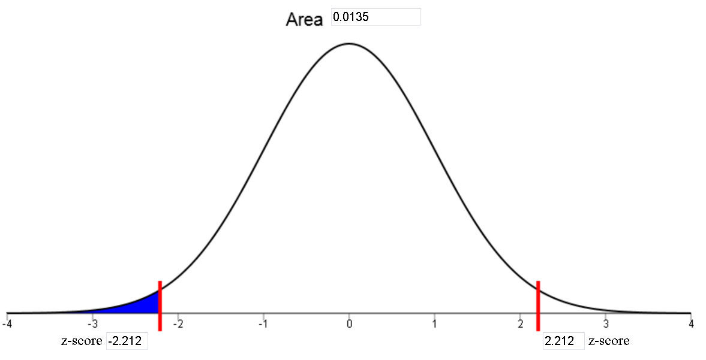

1. (1 pt.) Define a P-value.

**The probability of obtaining a test statistic at least as extreme as the one that was calculated, assuming that the null hypothesis is true.**

1. (1 pt.) What decision do you make based on the P-value and the level of significance (α)?

**The p-value is less than α (0.05) so we reject the null hypothesis.**

1. (1 pt) State your conclusion.

**We have sufficient evidence to say that the mean GMAT score from BYU-I students is less than the national average.**

1. (1 pt) What action item would you do given the results of your test?

**Answers may vary.**

1. (1 pt) What is the probability of committing a Type I Error in this study? **0.05 (Level of significance)**
2. (1 pt) What would be considered a Type I Error for this particular study? **Saying that the mean GMAT score for BYU-I students is less than the national mean when the means are the same.**
3. (1 pt) If we wanted to decrease the **probability of making a Type** II error, would we need to increase or decrease the level of significance?

**Increase the Level of Significance.**

**Level of Significance = Prob. Of Type I Error**

**As Prob. Of Type II error Decreases, Prob. Of Type I error Increases.**